Riget Zoo Adventures
Table of Contents
Interface Design 3
Sitemap 3
Mock-ups 4
Homepage 4
About Us Page 5
Attractions/Facilities Page 6
Policies Page 6
Login/Register Page 8
Account Dashboard 8
Zoo Safari Booking Page 9
Hotel Booking Page 11
Data Requirements 12
Data Dictionary 12
Entity-relationship Diagram 13
Algorithm Designs 14
Login Form 14
Register Form 15
Zoo Safari Booking 16
Test Strategy 17

Interface Design

Sitemap
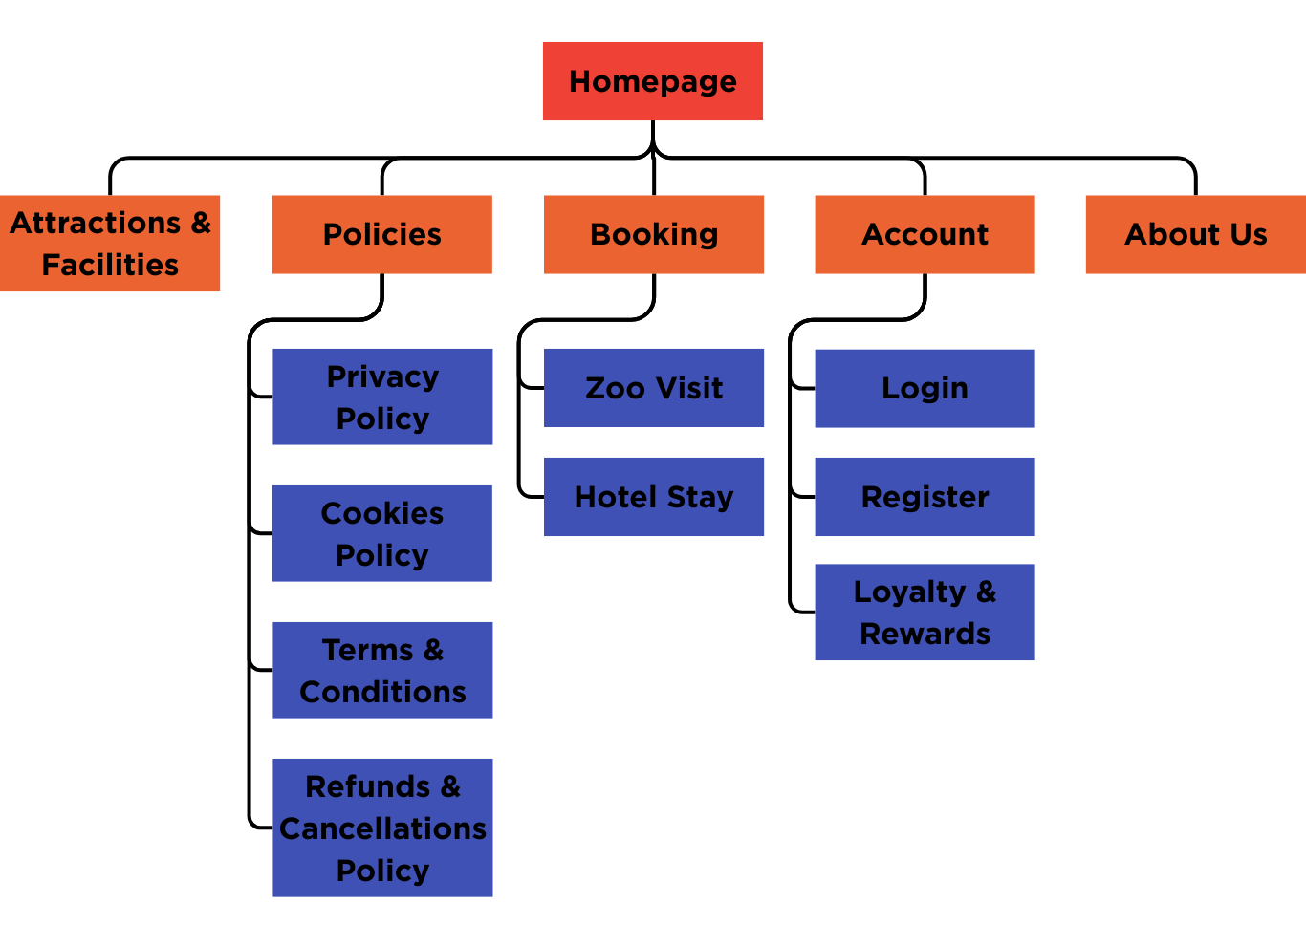

Mock-ups

Homepage
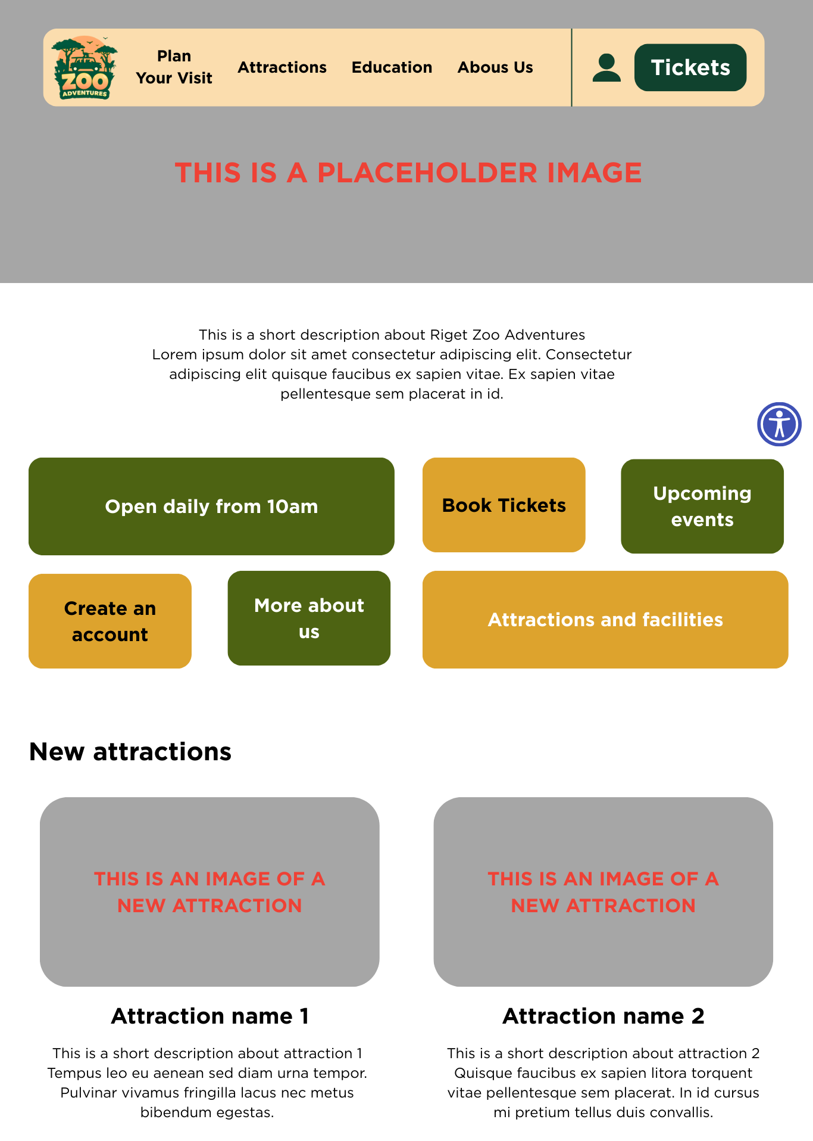

About Us Page
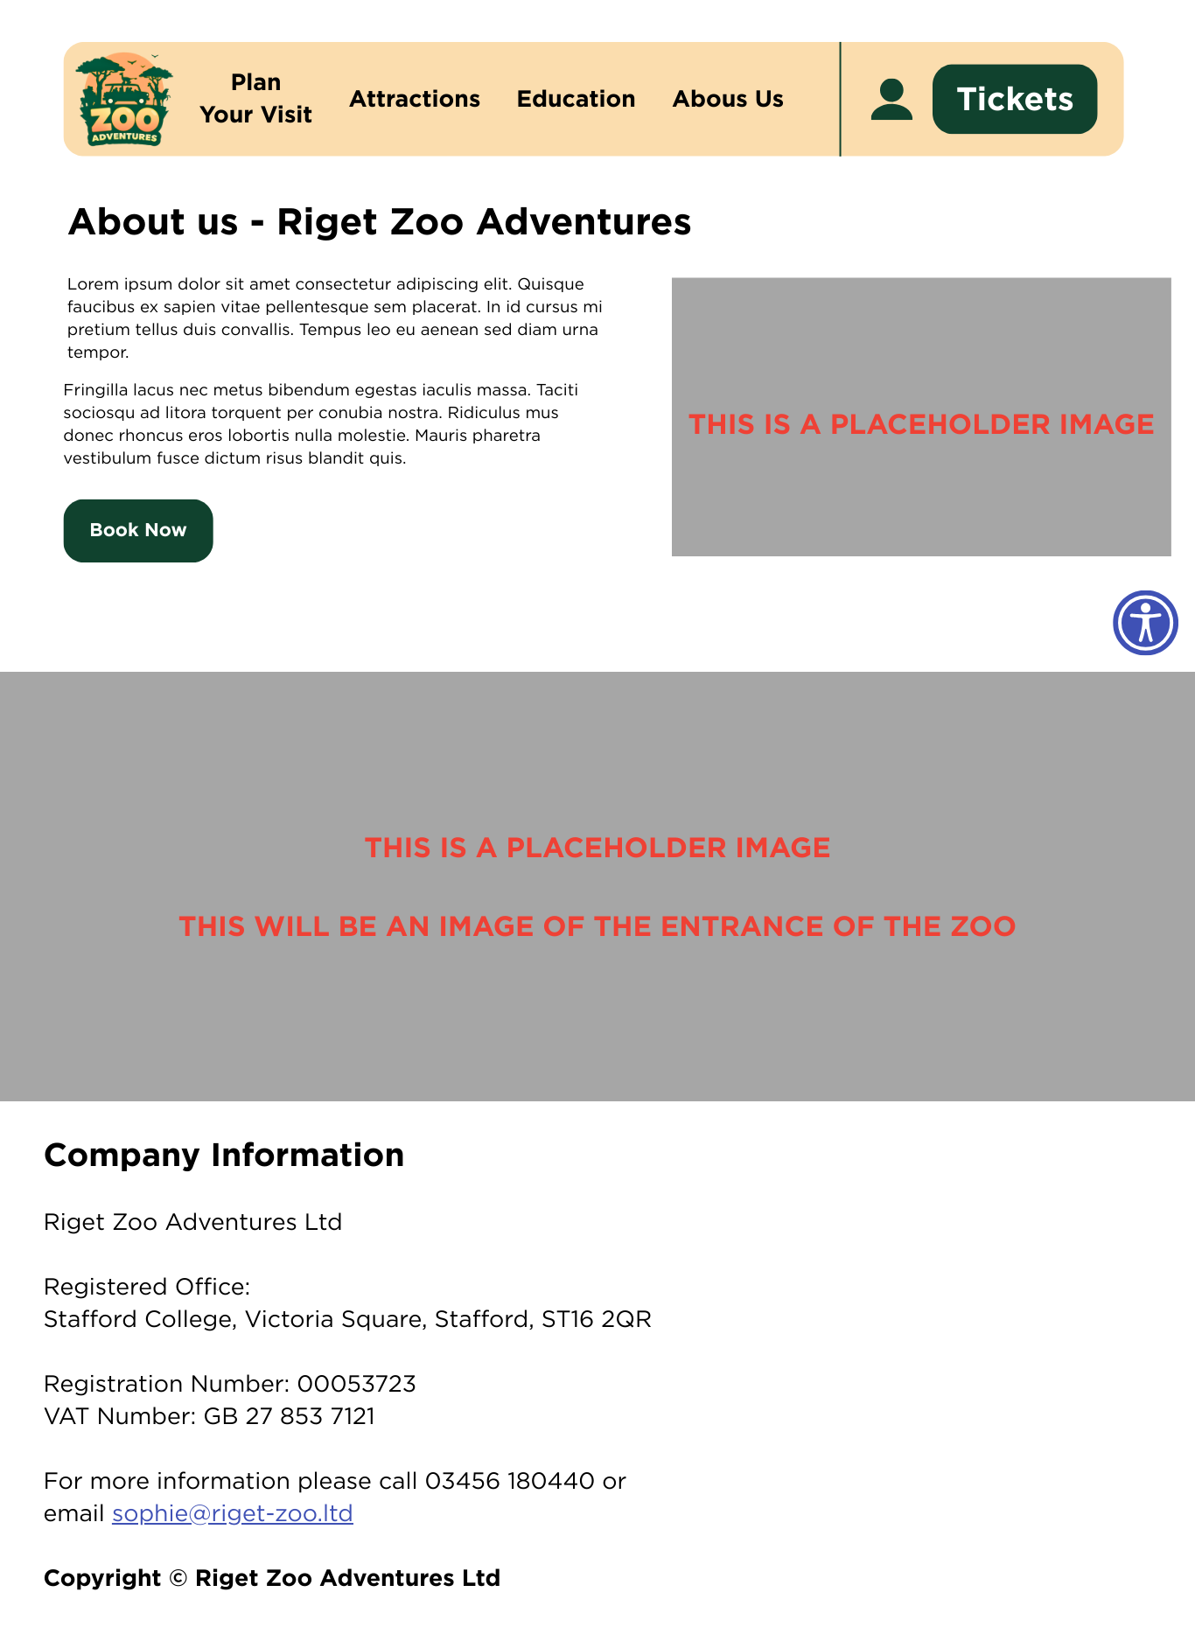

Attractions/Facilities Page
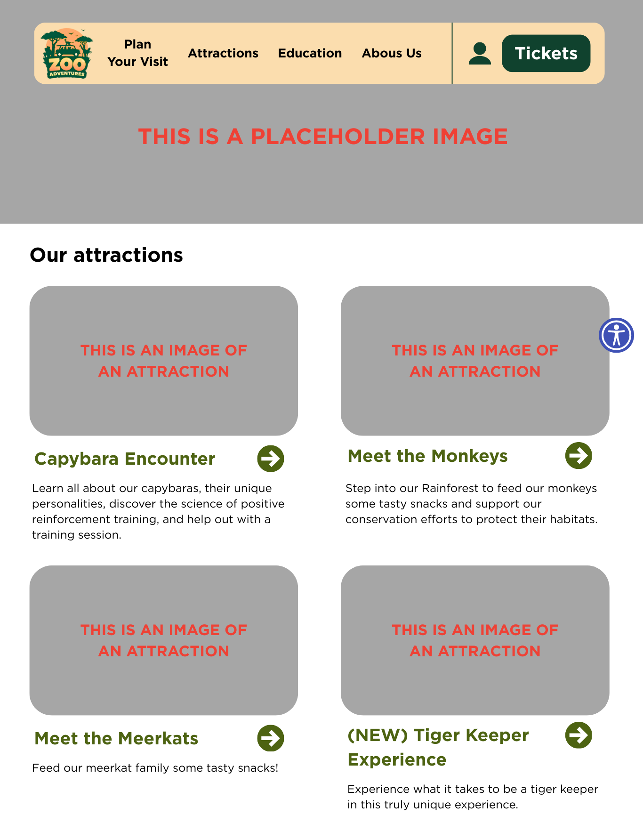

Policies Page
(Screenshot on next page)
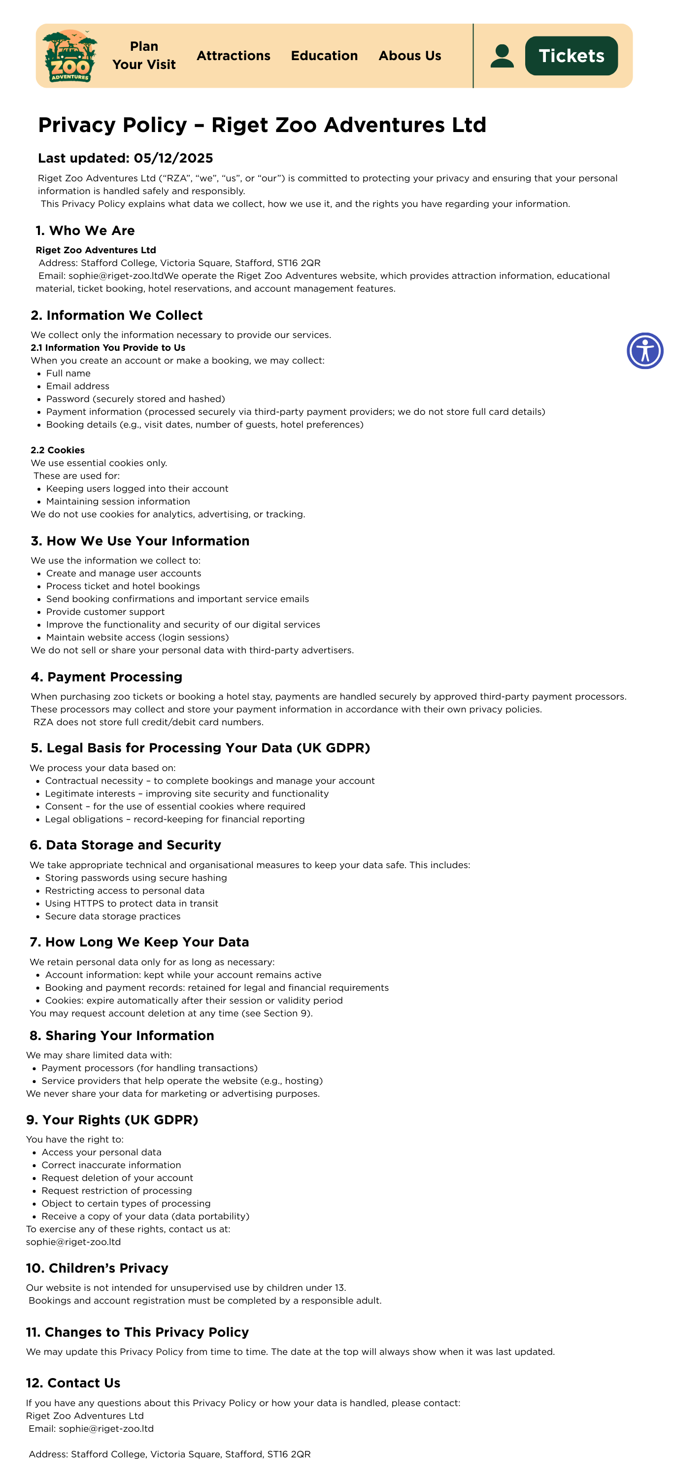

Login/Register Page
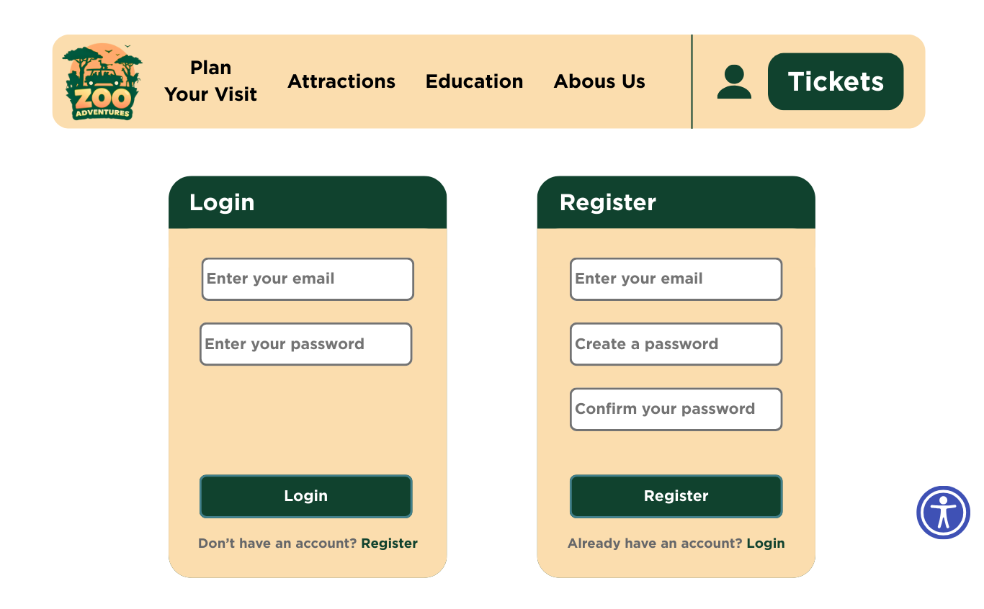

Account Dashboard
(Screenshot on next page)
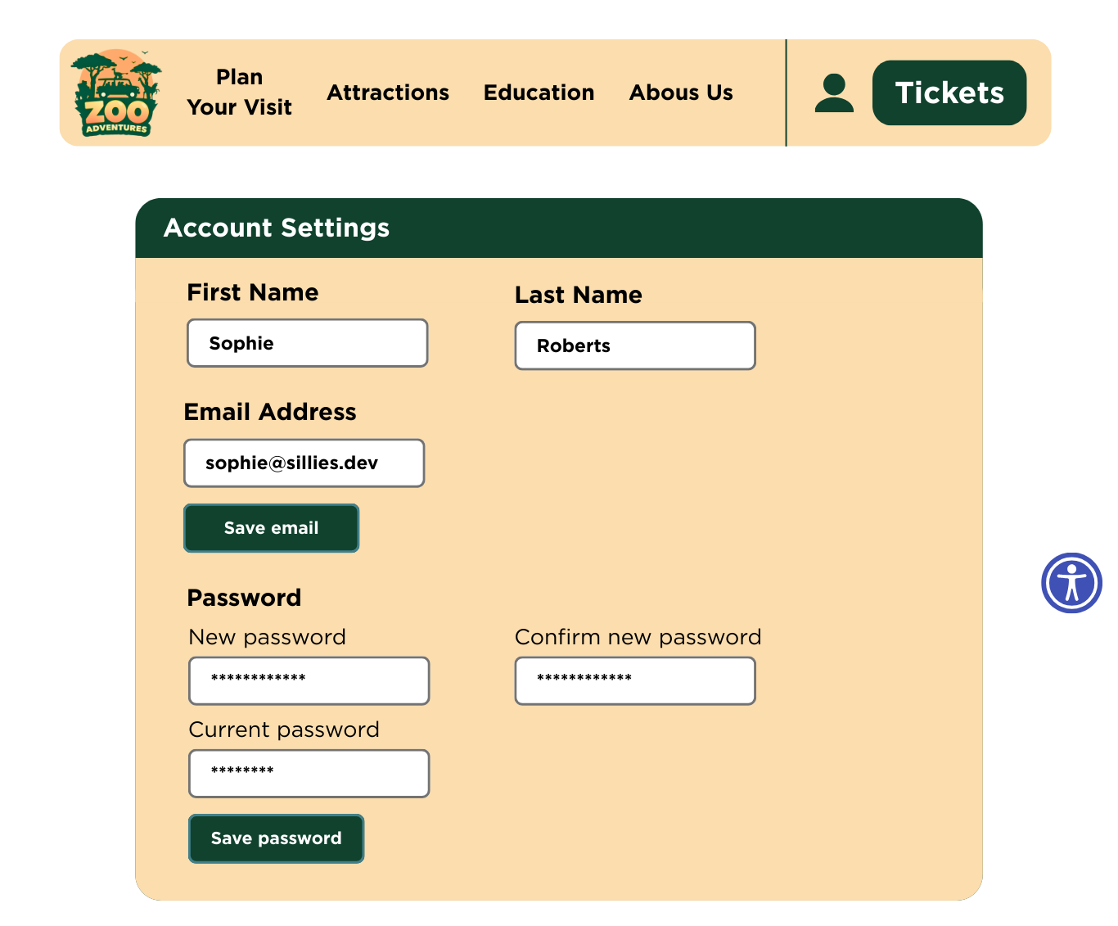

Zoo Safari Booking Page
(Screenshot on next page)
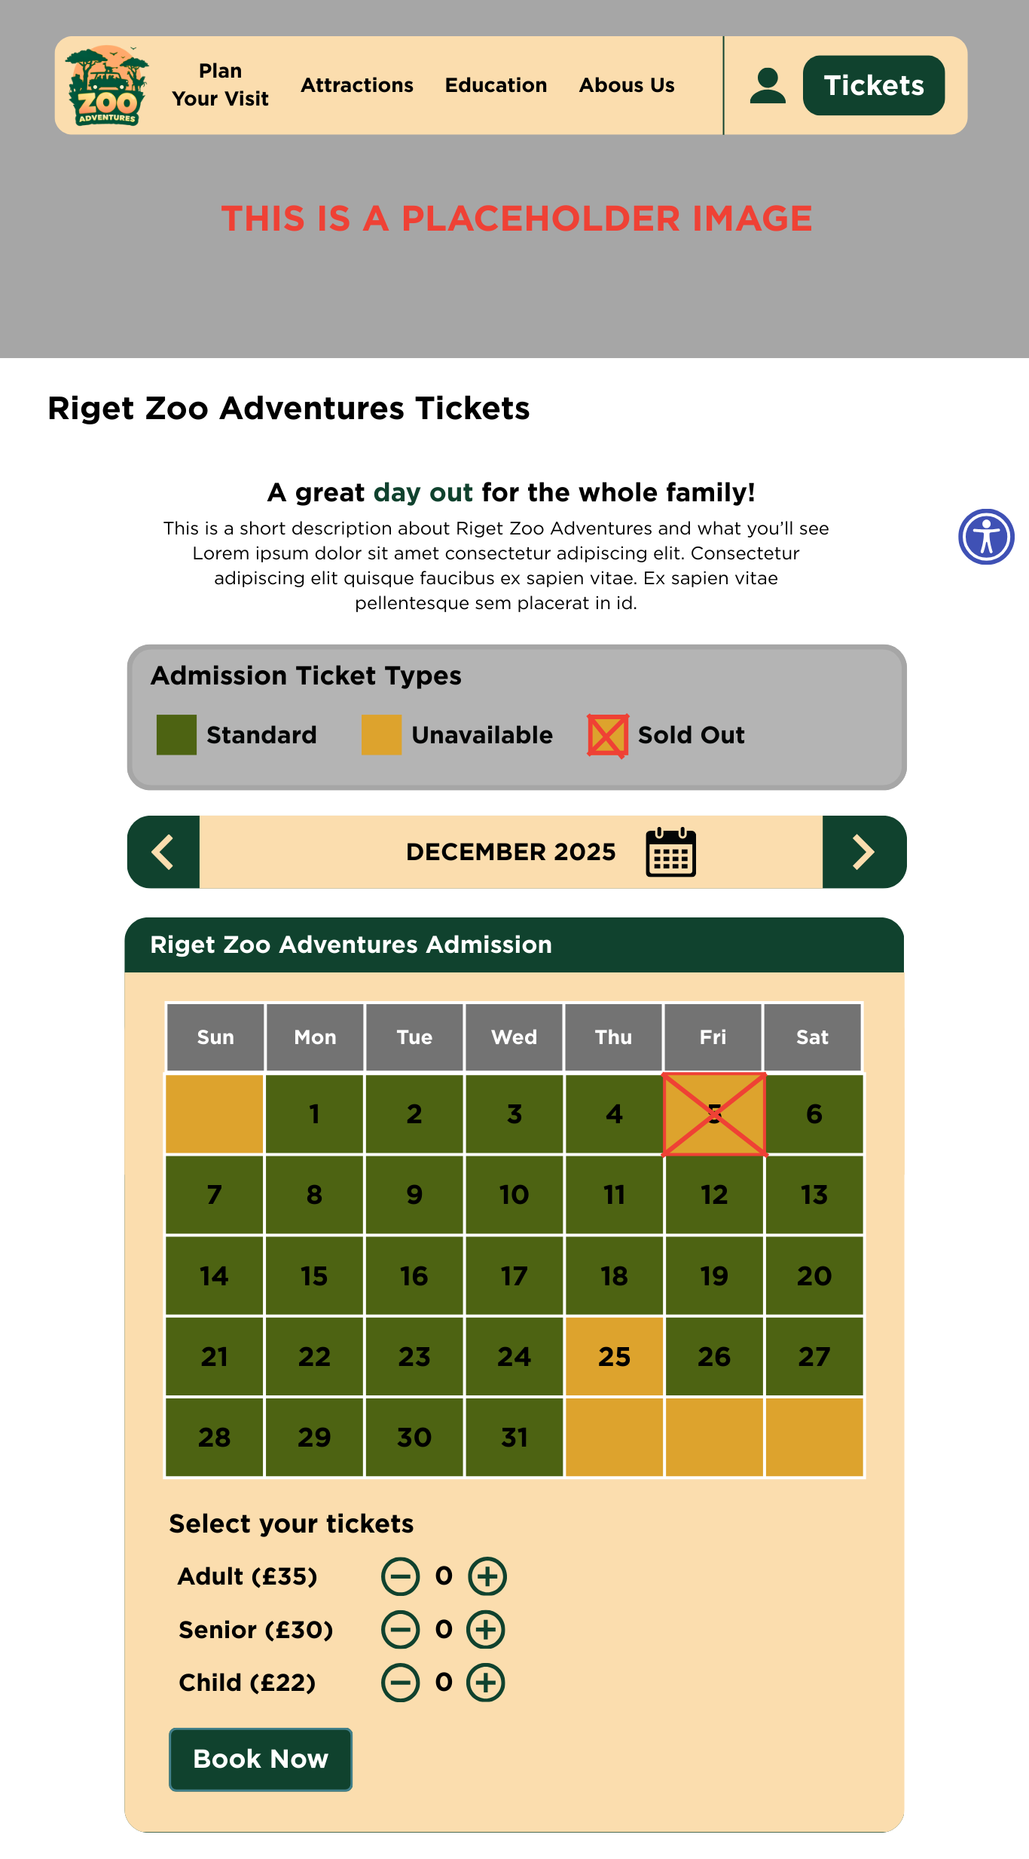

Hotel Booking Page
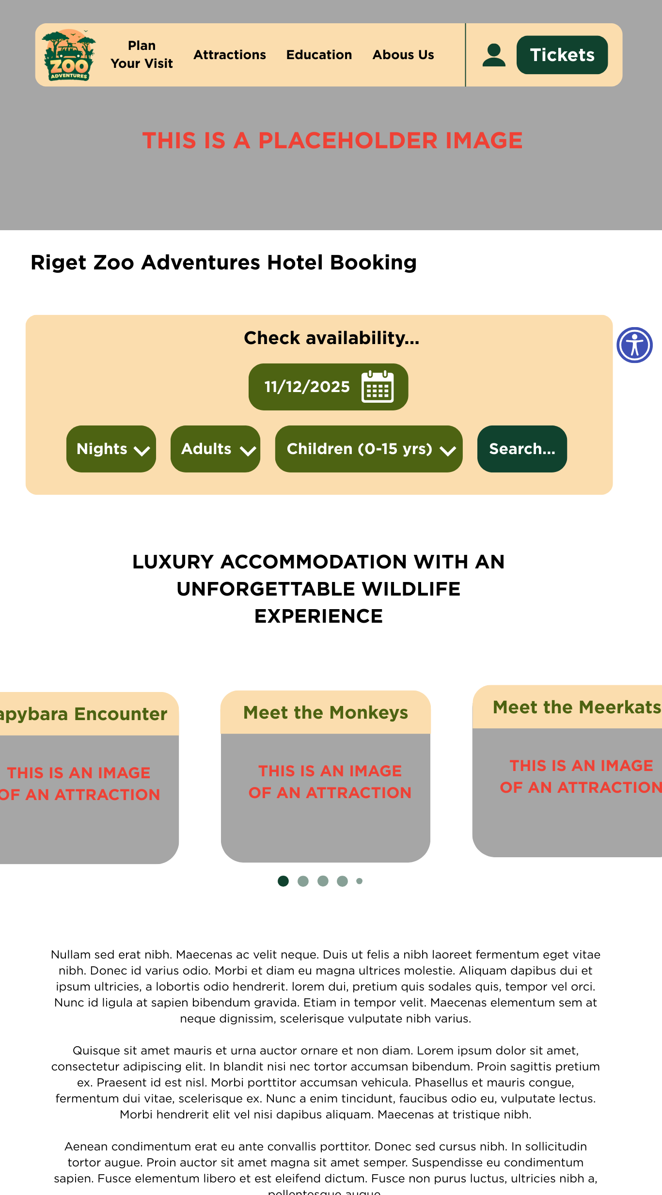

Data Requirements

Data Dictionary
Variable names | Data type | Field Size | Data format | Example | What is it for?
attraction_name | VARCHAR | 127 | N/A | Giraffe Adventures | This contains the name of the attraction
attraction_desc | VARCHAR | 1023 | N/A | We offer a Giraffe attraction where you can experience giraffes | This is the information about the attraction
ticket_id | UUID | 128-bit | xxxxxxxx-xxxx-xxxx-xxxx-xxxxxxxxxxxx | a0eebc99-9c0b-4ef8-bb6d-6bb9bd380a11 | The unique identifier of a ticket (no ticket should have the same ID)
ticket_date | DATE (ISO-8601) | 15 | YYYY-MM-DD | 2025-12-25 | The date in which the ticket is valid to be used
ticket_type | INT | 1 | N/A | 0 (child) or 1 (adult) or 2 (senior) | Stores whether the ticket is for an adult, child, or senior
ticket_price_child | DECIMAL | 8 | £xx.xx | £19.99 | The price for a child ticket
ticket_price_adult | DECIMAL | 8 | £xx.xx | £27.99 | The price for an adult ticket
ticket_price_senior | DECIMAL | 8 | £xx.xx | £24.99 | The price for a senior ticket
booking_id | UUID | 128-bit | xxxxxxxx-xxxx-xxxx-xxxx-xxxxxxxxxxxx | 0645ba9c-bc9c-4a93-ad3e-333a54c73d8c | The unique identifier of a booking (no booking should have the same ID)
hotel_room_no | UINT-16 | 16-bit | N/A | 68 | The number of the hotel room booked
hotel_room_type | INT | 1 | N/A | 0 (standard) or 1 (deluxe) or 2 (suite) | The type of the hotel room (determines price)
hotel_room_bed_count | INT | 1 | N/A | 2 | The number of beds in the hotel room (determines price)
hotel_room_price | DECIMAL | 8 | £xx.xx | £168.99 | The price of the hotel room per night
booking_date_start | DATE (ISO-8601) | 15 | YYYY-MM-DD | 2025-12-25 | The start date of the hotel booking
booking_date_end | DATE (ISO-8601) | 15 | YYYY-MM-DD | 2025-12-31 | The end date of the hotel booking
account_id | SERIAL INT | 64-bit | 1234 | 506762 | The unique ID of the user’s account, this increments for each sign up
account_email | VARCHAR | 255 | user@domain.tld | soap@sillies.dev | The user’s sign-up email
account_pass_hash | BLOB | 127 | N/A | $argon2id$v=19$m=16,t=2,p=1$OWFxUUdEV0h4UDNvY0ozZ | The Argon2ID hash of the user’s password
account_tickets | ARRAY[UUID] | Variable length | [x..x, y..y, z..z, ...] | [Daa252d9...1e3125c0, f88c82d1...7709a813] | A list of ticket_id that the account owns
account_bookings | ARRAY[UUID] | Variable length | [x..x, y..y, z..z, ...] | [Evv252d9...1eb128cc, a89c82d1...1706a81e] | A list of booking_id that the account owns
first_name | VARCHAR | 127 | N/A | Sophie | The user’s first name, for use on booking and tickets
last_name | VARCHAR | 127 | N/A | Roberts | The user’s last name, for use on booking and tickets

Entity-relationship Diagram
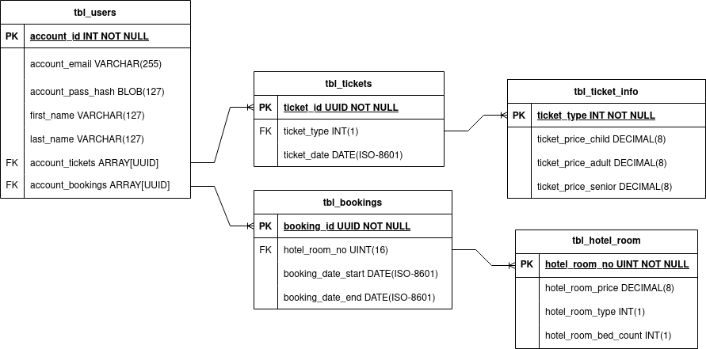

Algorithm Designs
(All algorithm designs are also available as PNG files in the ./assets/flowcharts folder, each named after its corresponding heading, in case they are unclear in this document)

Login Form
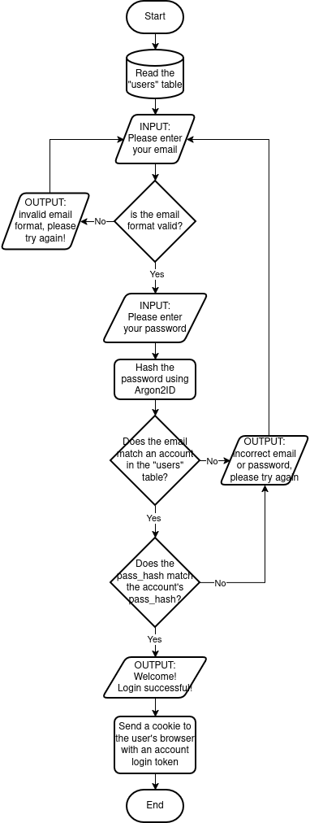

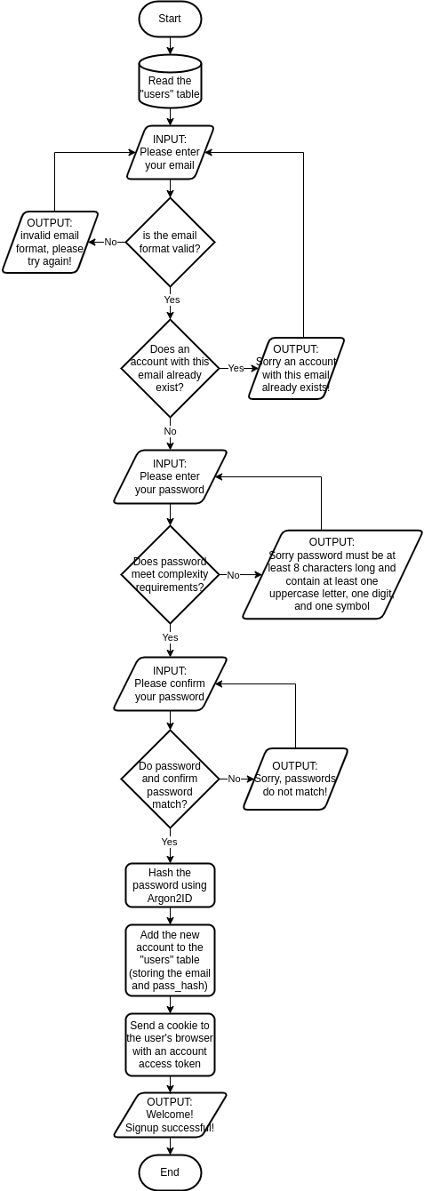
Register Form

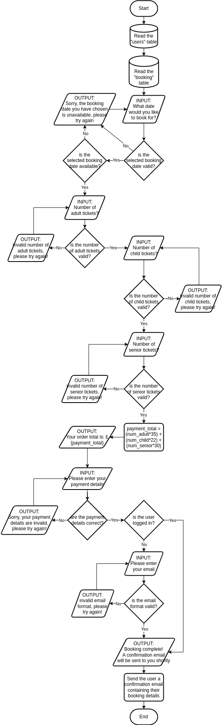
Zoo Safari Booking

Test Strategy
Date of test | Component to be tested? | Type of test to be carried out | Prerequisites and dependencies
10/12/2025 | Navigation bar – does it load? Is placement correct? Do the links work? | Unit test
10/12/2025 | Footer – does it load? Do the links work? | Unit test
10/12/2025 | Register form – does it load? | Unit test
10/12/2025 | Register form – does it accept valid data? | Unit test
10/12/2025 | Register form – does it reject invalid data? | Unit test
10/12/2025 | Login & Register forms – does the switch form button work? | Integration test | Login form, Register form
10/12/2025 | Login form – does it load? | Unit test
10/12/2025 | Login form – does it accept valid data? | Unit test
10/12/2025 | Login form – does it reject invalid data? | Unit test
10/12/2025 | Home page content – does it load? | Unit test
10/12/2025 | Home page content – do links work? | Unit test
10/12/2025 | Home page content – do images load correctly? | Unit test
10/12/2025 | Home page full – does it load? | Integration test | Navigation bar, Footer
10/12/2025 | Home page full – is the page responsive to mobile layouts? | Unit test | Navigation bar, Footer
10/12/2025 | Accessibility panel – does it load? Is the placement correct? | Unit test
10/12/2025 | Accessibility panel – can it increase/decrease font size? | Unit test | Accessibility panel
10/12/2025 | Accessibility panel – can it change font colour? | Unit test | Accessibility panel
10/12/2025 | Accessibility panel – can it remove animations and stop video auto-playing? | Unit test | Accessibility panel
10/12/2025 | Accessibility panel – can it change the font to be dyslexia-friendly? | Unit test | Accessibility panel
10/12/2025 | Accounts page – does it load? | Unit test
10/12/2025 | Accounts page – can users change their first name? | Unit test
10/12/2025 | Accounts page – can users change their last name? | Unit test
10/12/2025 | Accounts page – can users change their email address? | Unit test
10/12/2025 | Accounts page – can users change their password? | Unit test
10/12/2025 | About Us page – does it load? | Unit test
10/12/2025 | About Us page – do images load correctly? | Unit test
10/12/2025 | About Us page – do links work? | Unit test
10/12/2025 | Attractions page – does it load? | Unit test
10/12/2025 | Attractions page – do images load correctly? | Unit test
10/12/2025 | Attractions page – do links work? | Unit test
10/12/2025 | Cookies Policy page – does it load? | Unit test
10/12/2025 | Privacy Policy page – does it load? | Unit test
10/12/2025 | Refunds & Cancellations Policy page – does it load? | Unit test
10/12/2025 | Terms & Conditions page – does it load? | Unit test
10/12/2025 | Navigation bar – does the home page link work? | Integration test | Navigation bar, Home page
10/12/2025 | Navigation bar – does the accounts page link work? | Integration test | Navigation bar, Accounts page
10/12/2025 | Zoo Booking page – does it load? | Unit test
10/12/2025 | Zoo Booking page – do images load correctly? | Unit test
10/12/2025 | Zoo Booking form – does it accept valid dates? | Unit test | Zoo Booking page
10/12/2025 | Zoo Booking – does it reject invalid dates? | Unit test | Zoo Booking page
10/12/2025 | Zoo Booking form – does it accept valid ticket amounts? | Unit test | Zoo Booking page
10/12/2025 | Zoo Booking form – does it reject invalid ticket amounts? | Unit test | Zoo Booking page
10/12/2025 | Hotel Booking page – does it load? | Unit test
10/12/2025 | Hotel Booking page – do images load correctly? | Unit test
10/12/2025 | Hotel Booking page – does the image carousel work properly? | Unit test
10/12/2025 | Hotel Booking form – does it accept valid dates? | Unit test | Hotel Booking page
10/12/2025 | Hotel Booking form – does it reject invalid dates? | Unit test | Hotel Booking page
10/12/2025 | Hotel Booking form – does it accept valid number of nights? | Unit test | Hotel Booking page
10/12/2025 | Hotel Booking form – does it reject invalid number of nights? | Unit test | Hotel Booking page
10/12/2025 | Hotel Booking form – does it accept valid number of adults? | Unit test | Hotel Booking page
10/12/2025 | Hotel Booking form – does it reject invalid number of adults? | Unit test | Hotel Booking page
10/12/2025 | Hotel Booking form – does it accept valid number of children? | Unit test | Hotel Booking page
10/12/2025 | Hotel Booking form – does it reject invalid number of children? | Unit test | Hotel Booking page
10/12/2025 | Hotel booking form – does it return available rooms? Are the returned rooms relevant to the customer? | Unit test | Hotel Booking page
10/12/2025 | Navigation bar – does the plan your visit (booking page) link work? | Integration test | Navigation bar, Zoo Booking page, Hotel Booking page
10/12/2025 | Navigation bar – does the about us page link work? | Integration test | Navigation bar, About Us page
10/12/2025 | Navigation bar – does the attractions page link work? | Integration test | Navigation bar, Attractions page
10/12/2025 | Navigation bar – does the educational information page link work? | Integration test | Navigation bar, Educational Information page
10/12/2025 | Footer – does the privacy policy page link work? | Integration test | Footer, Privacy Policy
10/12/2025 | Footer – does the cookies policy page link work? | Integration test | Footer, Cookies Policy
10/12/2025 | Footer – does the terms & conditions page link work? | Integration test | Footer, Terms & Conditions
10/12/2025 | Footer – does the refunds & cancellations policy page link work? | Integration test | Footer, Refunds & Cancellations Policy

